COUSCOUS PILAF
Serves: 4-6

An instant side dish! Use whole wheat couscous for added nutrition and herbs for flavor with no added calories or salt. | Cost Per Recipe  Cost Per Person | Time Required  Prep: 5mins  Cook: 5mins | 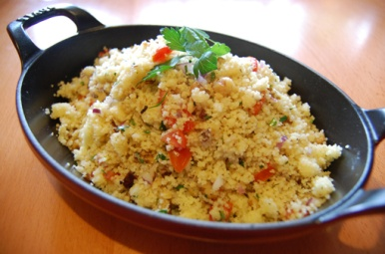

Ingredients | Procedure
- 1 ¼ cups water or reduced-sodium chicken broth  - ½ teaspoon hot sauce (optional)  - ¼ teaspoon salt  - 1 ½ cups whole-wheat couscous  - 1 Tbs fresh parsley or 2 teaspoons dried parsley  All of this can be bought at Schnucks (whole wheat couscous not available at Aldi) | - Combine broth or water, hot sauce, and salt in a small saucepan with a tight-fitting lid and bring to a boil.  - Remove from heat and stir in couscous.  - Let stand for 5 minutes; uncover and stir in parsley.

Other Thoughts / Variations on the Recipe / Nutrition Information
- You can make endless variations of this dish – try it with dried fruit and nuts, or any herb combination. Consider sautéed onions and garlic, of course being cost conscious.
- You can substitute regular (ie not whole wheat) couscous, but note to volunteers that it’s not a whole grain!
- Focus participants on how amazingly quick couscous is to prepare.
- Focus participants on how useful herbs are for adding flavor without fats and salts.

