Oven Baked Fish Sticks
Serves: 4-6

You can make these homemade fish sticks in about the same amount of time as it takes to make frozen (and deep fried) fish sticks. The tartar sauce is much healthier than the store-bought variety. | Cost Per Recipe  Cost Per Person | Time Required  Prep: 20mins  Cook: 10mins | 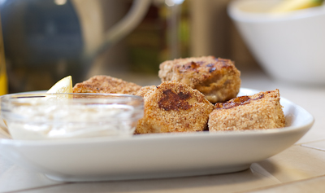

Ingredients | Procedure
Fish:  * 2 cups panko or regular bread crumbs  * 1.5 pounds tilapia or cod fillets (frozen or fresh)  Marinade:  * 3 Tbs Greek yogurt (nonfat is fine)  * 1 Tbs Dijon mustard  * 1 Tbs dried oregano (optional)  * ¼ teaspoon salt  * ¼ teaspoon garlic powder  *nonstick cooking spray  Tartar Sauce:  *1/2 cup Greek yogurt (nonfat is fine)  *1 Tbs dried dill  *2 Tbs finely chopped dill pickles  *1 Tbs pickle juice from jar  *splash lemon juice  All of this can be bought at Aldi / Shop n Save / Schnucks | - Preheat oven to 450F. Place a baking sheet on the middle rack.  - Toast the bread crumbs in a medium skillet over medium-low heat until lightly browned and fragrant. Transfer to a plate.  - Cut fish into 1 inch strips.  - In a shallow bowl, combine the marinade ingredients.  - One piece at a time, dunk in the marinade and then move into the breadcrumbs. Once the fish is breaded, move to a clean plate. Repeat with remaining fish.  - Remove the hot baking sheet from the oven and coat with nonstick cooking spray. Carefully place each piece of fish on the hot baking sheet, with room between each piece.  - Return the tray to the oven and bake for 10 minutes, or until the fish flakes easily and is golden brown.  - While the fish is cooking, prepare the tartar sauce by combining all ingredients.

Other Thoughts / Variations on the Recipe / Nutrition Information
- The Greek yogurt is very high in protein, and if nonfat or lowfat, then also very low in fat. It gives the creaminess of mayonnaise without the fat.
- Focus participants on the idea that mayonnaise is the normal sauce of choice but that tartar sauce tastes just as good, but is much healthier. You can consider buying a tartar sauce, but it’s hard to find a healthy version of tartar sauce that’s cheap.

