MASSAGED KALE SALAD
Serves: 4-6

Kale is really cheap – only $0.99 per head at Schnucks! Try this salad as an excellent way to eat more greens – in a quick and delicious salad. | Cost Per Recipe  Cost Per Person | Time Required  Prep: 10mins  Cook: n/a | 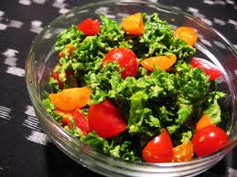

Ingredients | Procedure
- 1 head kale (curly or lacinato)  - 1/2 pint cherry tomatoes, quartered (optional)  - 1 teaspoon (extra virgin) olive oil  - 2-3 tablespoons lemon juice (one medium lemon)  - pinch salt (approx ⅛ tsp)  All of this can be bought at Aldi / Shop n Save / Schnucks | 1. Strip the kale from the stem and roughly tear by hand.  2. Clean by soaking in water-filled bowl or salad spinner; lift out greens, rinse bowl, and repeat until the water runs clear. Don't tip bowl over with greens in it, because the dirt just goes back into the leaves!  3. Dry the greens in salad spinner or with dry kitchen towels and put into a clean bowl. Add olive oil, lemon juice & salt. Massage with your hands to help the kale soften and absorb the delicious flavor! It’s ready when the leaves are darker and starting to look translucent. They will no longer taste raw, but will instead taste marinated.  4. Add tomatoes and adjust seasoning as desired. Kale will keep for up to three days in the refrigerator.

Other Thoughts / Variations on the Recipe / Nutrition Information
- Focus participants on how inexpensive and quick this highly nutritious salad is.

