## Choosing whole grains

Eat whole-grain versions — rather than refined grains — as often as possible. Whole-grain versions of rice, bread, cereal, flour and pasta can be found at any grocery store. Many whole-grain foods come ready to eat. These include a variety of breads, pastas and ready-to-eat cereals.

Examples of whole grains include:

* Barley
* Brown rice
* Buckwheat
* Bulgur (cracked wheat)
* Millet
* Oatmeal
* Popcorn
* Whole-wheat bread, pasta or crackers
* Wild rice

**Ways to enjoy more whole grains**

Try these tips for adding more whole grains to your meals and snacks:

* Enjoy breakfasts that include high-fiber cereals, such as bran flakes, shredded wheat or oatmeal.
* Substitute whole-wheat toast or whole-grain bagels for plain bagels. Substitute low-fat, bran muffins for pastries.
* Make sandwiches using whole-grain breads or rolls. Swap out white-flour tortillas with whole-wheat versions.
* Replace white rice with kasha, brown rice, wild rice or bulgur.
* Feature wild rice or barley in soups, stews, casseroles and salads.
* Add whole grains, such as cooked brown rice or whole-grain bread crumbs, to ground meat or poultry for extra body.
* Use rolled oats or crushed bran cereal in recipes instead of dry bread crumbs.

## Can white bread really be whole wheat?

Yes. Although white whole-wheat bread looks and tastes like white bread, it has the same nutritional benefits as regular whole-wheat or whole-grain bread. White whole-wheat bread is made with an albino variety of wheat, which is lighter in color and has a sweeter, milder flavor. Regular whole-wheat bread is made with red wheat, which is dark in color and has a slightly bitter taste. White whole wheat also has a softer texture, because it goes through an extra processing step.

When you're selecting any kind of bread, read the label carefully. Choose breads that list "whole" grain as the first ingredient, such as whole wheat, white whole wheat or whole oats. If the label doesn't say "whole" first, it isn't a whole-grain product. For example, a product label may simply say white wheat, which is not the same as white whole-wheat bread.

source: http://www.mayoclinic.com/health/whole-grains/NU00204

**Reducing Sugar in Your Diet**

* Avoid sugary, nondiet sodas. Drink water or other unsweetened beverages instead.
* Choose breakfast cereals carefully. Although healthy breakfast cereals can contain added sugar to make them more appealing to children, skip the non-nutritious, sugary and frosted cereals.
* Eat fewer processed and packaged foods, such as sweetened grains like cookies and cakes and some microwaveable meals.
* Snack on vegetables, fruit, low-fat cheese, whole-grain crackers, and low-fat, low-calorie yogurt instead of candy, pastries and cookies.

source: <http://www.mayoclinic.com/health/high-fructose-corn-syrup/AN01588>

Compare a food with fiber to one without:

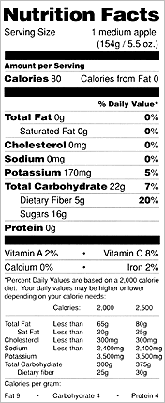 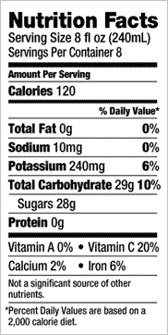

Apple, raw (medium-sized) Apple Juice (8 fl oz = 1 cup)