**Leisha:**

Breakfast: skipped it--too busy!

Snack: blueberry muffin

Lunch: turkey sandwich and chili

Snack: Coke and bag of Doritos

Dinner: too tired to cook--picked up fried chicken and mashed potatoes and gravy from KFC on the way home.

Dessert: ice cream and fruit

|  |  |
| --- | --- |
| Healthy Things ☺ | Unhealthy Things ☹ |
|  |  |

**Robert:**

Breakfast: bowl of frosted mini-wheats in skim milk and coffee

Snack: starving--ate a donut

Lunch: drove through McDonald's on the way to pick up kids

Snack: hungry again--drank a Coke and ate a bag of pretzels

Dinner: Velveeta's macaroni and cheese with hot dog.

|  |  |
| --- | --- |
| Healthy Things ☺ | Unhealthy Things ☹ |
|  |  |

**Kid Mia:**

Breakfast: whole wheat toast with peanut butter and bananas, glass of skim milk

Snack: none

Lunch: pizza and small salad from school cafeteria

Snack: apple, chocolate chip cookies

Dinner: roasted chicken and green beans

Dessert: Jell-O

|  |  |
| --- | --- |
| Healthy Things ☺ | Unhealthy Things ☹ |
|  |  |

Sample Nutrition Label: Macaroni and Cheese

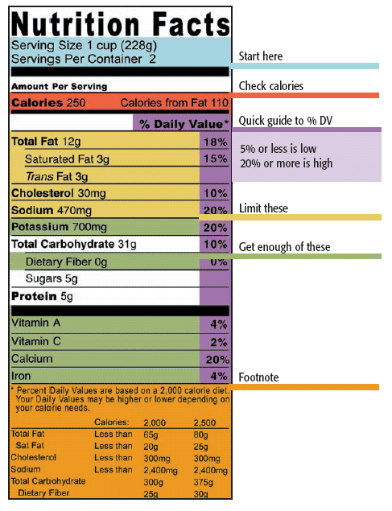

Avocado

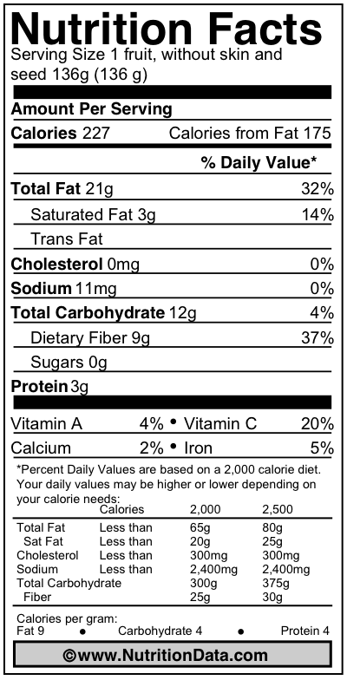

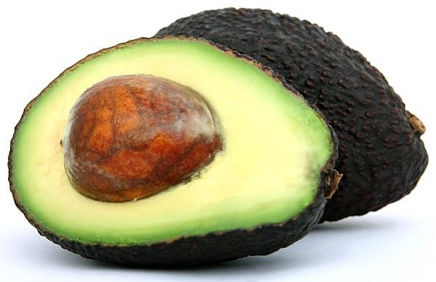

Banquet Hearty Ones: Salisbury Steak Dinner w/ Gravy, Mashed Potatoes and Corn

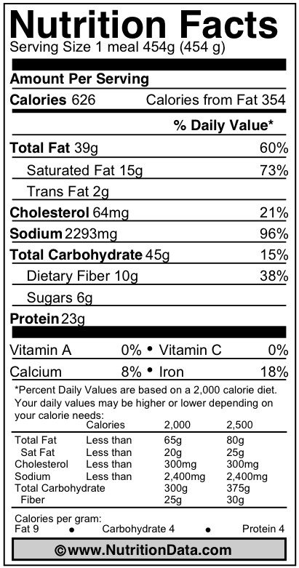

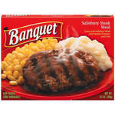

Campbell’s Chunky Beef Stew

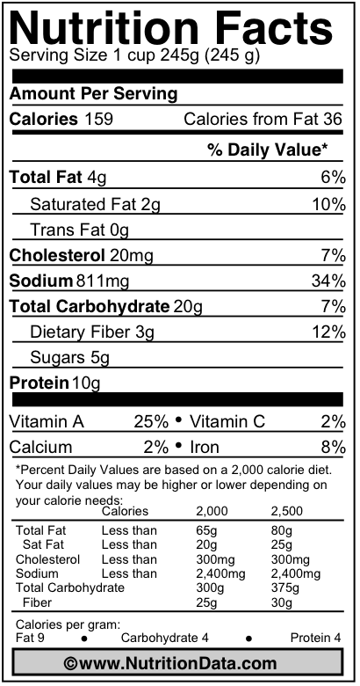

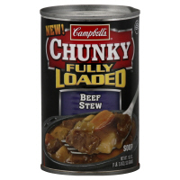

Chicken Ramen Noodles

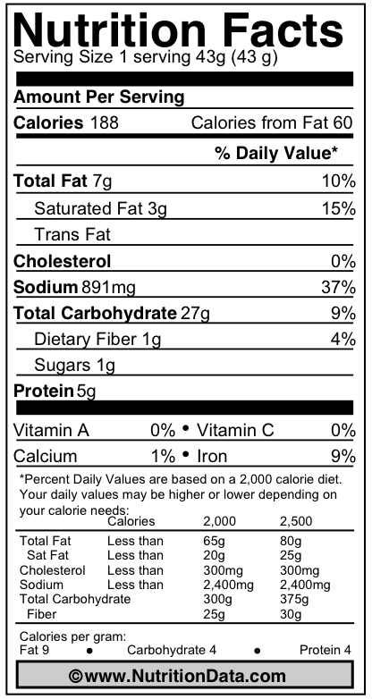

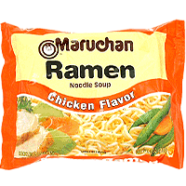

Dairy Queen Dipped Ice Cream Cone

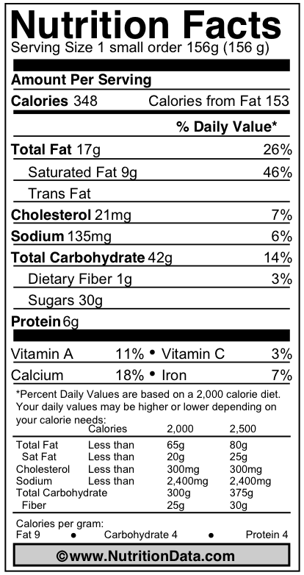

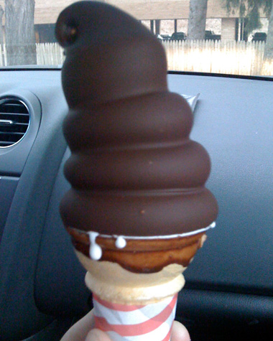

**Hungry Man All Day Breakfast**

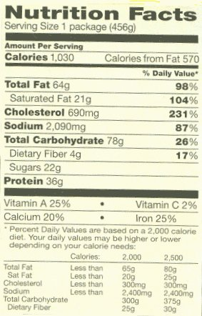

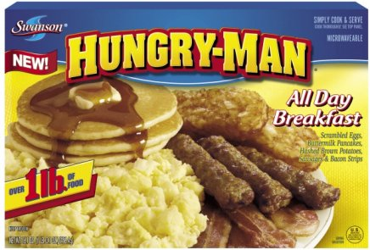

Kraft Macaroni and Cheese Dinner

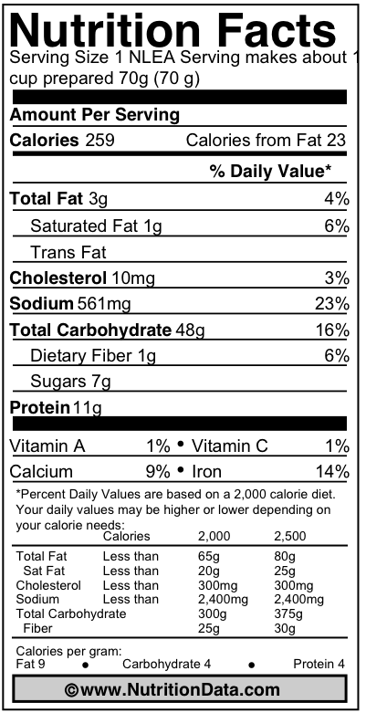

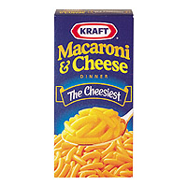

McDonald’s Double Quarter Pounder with Cheese

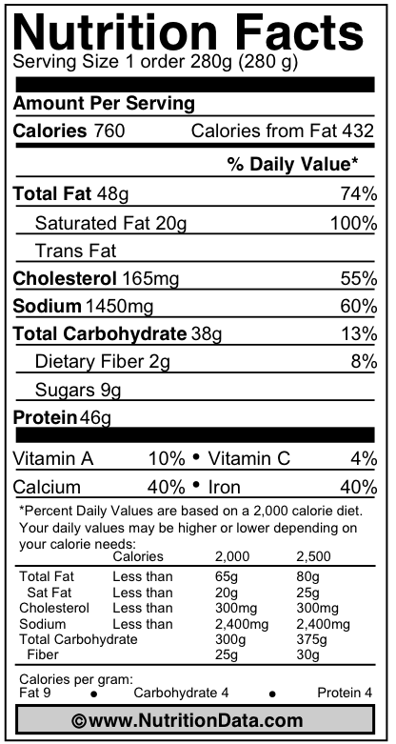

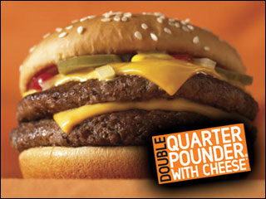

Peanuts (1/4 Cup)

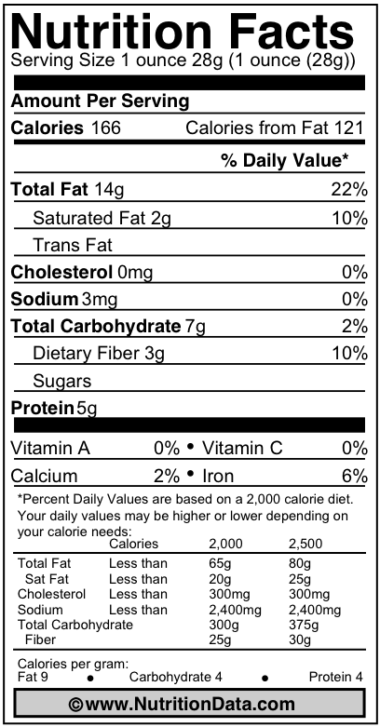

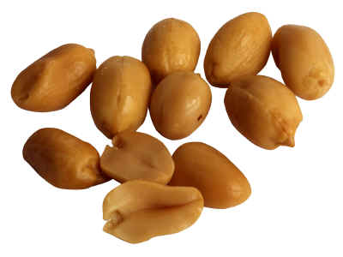

Pillsbury Grand Buttermilk Biscuits

